# PROPOSED METHODS

# There are two phases in our proposed method:

# The first phase is to classify the currency note based on denomination

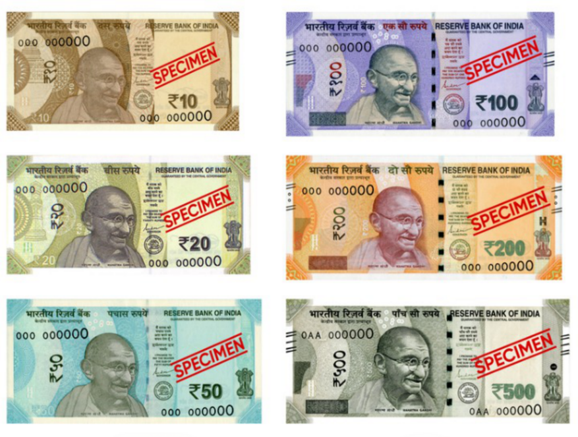

# Second phase is to check whether the note is Real or Counterfeited.

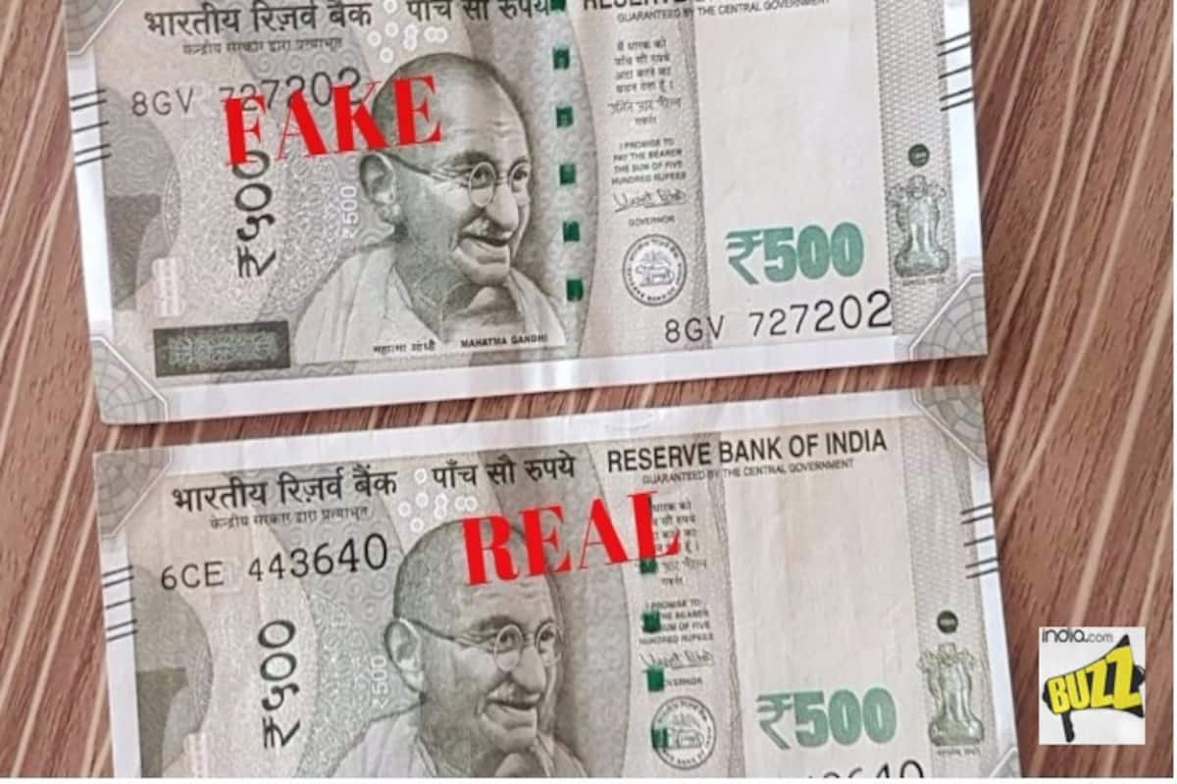

# CLASSIFICATION BASED ON DENOMINATION

## 1.1 INTRODUCTION

The Indian currency system includes banknotes and coins, among which banknotes are the primary form of currency used in abundance. Senior citizens experience presbyopia, a natural loss of the ability to focus, which causes difficulty identifying the denomination of banknotes. With introducing additional currency notes post demonetization in India, blind people have not been accustomed to the fresh notes, and identification of notes is a hassle. Scammers use this to their advantage to dupe the blind and elderly and give them the wrong denominations. With the demonetization of old ₹500 and ₹1000 notes, new ₹500 and ₹2000 currency notes were introduced, which brought lots of hardships to the visually impaired. It was difficult for them to recognize the new notes. A system to recognize the correct denominations of the currency notes is much needed, and this study proposes to do just that by using deep learning. Most of the currently existing methods for verifying the validity of a banknote rely on hardware systems with Ultraviolet light. These hardware systems are only available in banks and not accessible to vendors or the public. By leveraging deep learning techniques, particularly convolutional neural networks (CNNs), the system can analyze scanned images of banknotes to accurately identify their denominations. This approach eliminates the need for specialized hardware and extends the capability to verify currency authenticity beyond the confines of banking institutions.

## 1.2 PROBLEM STATEMENT

Visually impaired individuals encounter considerable obstacles when it comes to managing their finances autonomously. A primary challenge they face is the inability to identify and differentiate between various currency denominations accurately. This difficulty arises due to the reliance on visual cues that sighted individuals use effortlessly. Existing solutions, such as relying on assistance from others or utilizing specialized devices, have limitations that impede the independence and efficiency of visually impaired individuals in managing their finances effectively.

To address these challenges effectively, there is a pressing need for a solution that provides real-time, accurate, and efficient currency recognition for visually impaired individuals. Such a solution should leverage modern technologies, such as artificial intelligence and smartphone applications, to offer a seamless and accessible user experience. By empowering visually impaired individuals to independently manage their finances, this solution can enhance their autonomy, confidence, and overall quality of life.

## 1.3 LITERATURE REVIEW

* **Rashmi C et al. (2016),** an algorithm is proposed for real time application to an existing automated teller machine (ATM) using image processing in currency note number recognition. Sometimes getting fake currency notes from ATM nowadays has become a major issue leading to an ultimate loss to common people. Common people are afraid to complain regarding this to respective banks and live in hope that may recover their money from respective banks. An algorithm is developed for automatically noting and saving the currency note number to server at the time of withdrawal, so that customers are benefitted in recovering their currency back. The proposed algorithm makes the ATMs more reliable, user friendly and efficient usage to the customers.
* **Vedasamhitha Abburu et al. (2017),** developed a system for automated currency recognition using image processing techniques which can be used for recognizing both the country or origin as well as the denomination or value of a given banknote. Only paper currencies have been considered. This method works by first identifying the country of origin using certain predefined areas of interest, and then extracting the denomination value using characteristics such as size, color, or text on the note, depending on how much the notes within the same country differ. Here considered 20 of the most traded currencies, as well as their denominations. When compared with the crude algorithm of pixel by pixel comparison, our algorithm is considerably more accurate, and takes less time. Proposed algorithm is able to identify currency and denomination in an average of 5.3 seconds, which is a considerable improvement over the crude algorithm. However, proposed system only considers a limited number of currencies. There are 180+ currencies that can be included in the system, and we have chosen to only do for 20 of the most common ones. Also, the system should be effective in identifying notes that are mutilated. This system is not effective under this consideration

## 1.4 USE CASES

* **Independent Shopping:**
* Visually impaired individuals struggle with identifying currency denominations while shopping independently.
* Lack of real-time currency recognition hampers their ability to manage transactions effectively.
* Accessibility barriers in stores, such as navigating aisles and locating products, pose challenges.
* **Public Transportation:**
* Visually impaired individuals encounter difficulties in accessing transportation schedules and routes.
* Inadequate audio announcements and signage on public transportation vehicles lead to confusion and missed stops.
* Limited options for purchasing tickets independently hinder their ability to use public transportation autonomously.

## 1.5 BENEFITS

* **Empowering Independence:**
* Independence in financial matters enhances individuals' confidence and autonomy, leading to greater overall satisfaction and well-being.
* Empowering visually impaired individuals to handle their finances autonomously promotes their integration into society and reduces reliance on external assistance.
* **Real-Time Accuracy:**
* Real-time currency recognition and transaction processing ensure accurate and efficient financial interactions for visually impaired individuals.
* Real-time accuracy enhances the efficiency of financial transactions, saving time and effort for both users and service providers.
* **Inclusive Financial Participation:**
* By removing barriers to financial participation, such as lack of support for assistive technologies, the solution enables equal access to banking, shopping, and other financial activities.
* Inclusive financial participation promotes economic empowerment and social inclusion, allowing visually impaired individuals to fully engage in economic activities and contribute to society.

# 1.6 OBJECTIVE

The primary objective of this project is to develop a robust currency classification system that utilizes advanced machine learning and deep learning techniques. The system aims to empower visually impaired individuals by providing them with a reliable tool capable of accurately recognizing and differentiating between the currencies of India, China, and the USA in real-time. By leveraging cutting-edge technology, the project seeks to address a critical need for an inclusive and empowering solution that enhances the quality of life for visually impaired individuals in the realm of financial independence.

Ultimately, the project aims to empower visually impaired individuals to handle their financial affairs confidently and independently, reducing their reliance on external assistance. By providing a reliable tool for currency recognition, the system promotes financial inclusion and autonomy for visually impaired individuals. The project will assess the impact of the developed system on the lives of visually impaired individuals and evaluate its scalability for broader adoption, demonstrating the potential of technology to improve the quality of life for individuals with visual impairments and promote inclusivity in financial transactions on a global scale.

**1.7 OVERALL SYSTEM ARCHITECTURE OF CURRENCY CLASSIFICATION**

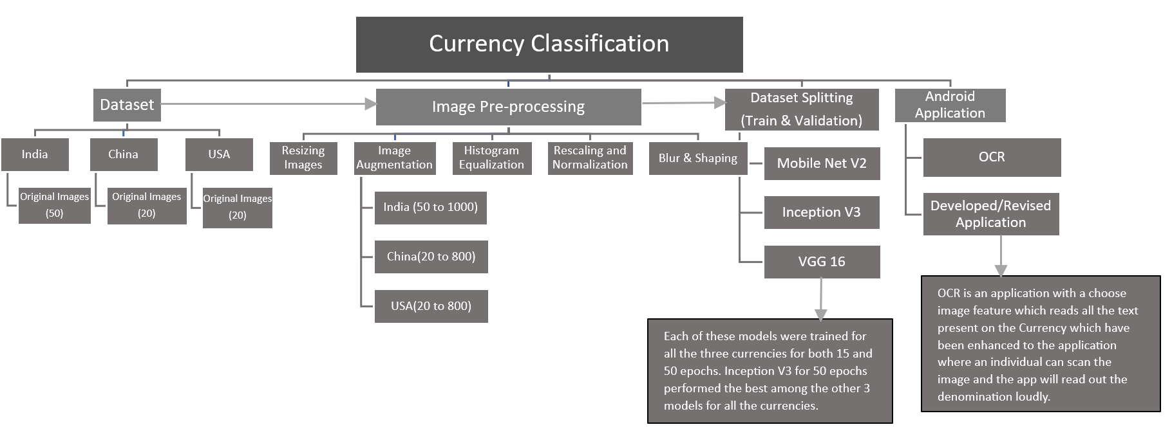

Fig 1.9 Overall Architecture of Currency Classification

This process diagram outlines a mobile app for classifying currency using image recognition. Images from India, China, and the USA are preprocessed and fed into three machine learning models (MobileNet V2, Inception V3, VGG16) for training. Inception V3 shows the best performance across all currencies. Finally, an OCR layer was added to read the denomination and then it was enhanced to more advance manner where an individual can scan and upload the image to know the denomination of a particular Indian Currency note, and everything is deployed as a mobile app for users to classify currency with their phone cameras.

**1.8 DATASET**

**Data Collection of Indian Currency**

For Indian currency identification, a dataset was meticulously curated, comprising manually captured images of 10, 20, 50, 100, 200, and 500 rupee notes. Each denomination was represented by 50 images, ensuring diversity and coverage across different variations.

**Data Collection of US Dollars**

In the case of US dollars, data collection involved sourcing images from Google Chrome, with 20 images collected for each currency class. The dataset includes images of various US dollar denominations, ranging from $1 to $100 bills. While the dataset size may be relatively smaller compared to the Indian rupee dataset, to ensure representation across different denominations and variations.

**Data Collection of Chinese Yuan/Renminbi**

For Chinese yuan identification, data acquisition also relied on Google Chrome, with 20 images collected for each currency class. The dataset covers a range of Chinese yuan denominations, including ¥1, ¥5, ¥10, ¥20, ¥50, and ¥100 bills. Despite the smaller dataset size, attention was paid to capturing diverse images to account for variations in appearance and features across different currency denominations.

**1.9 PRE-PROCESSING OF INDIAN, CHINESE AND USD CURRENCY NOTES**

In the project, a series of image preprocessing techniques were implemented to optimize the dataset and enhance model performance. Before training the models, the dataset underwent preprocessing to ensure its quality and suitability for model training.

**Image Preprocessing Techniques used:**

**A. Resizing Images:** The dimensions of currency images were standardized by resizing them to 224x224 pixels. This uniform size simplifies model training and ensures consistency across the dataset, which is crucial for accurate currency recognition.

**B. Image Augmentation:** To address the limited number of original currency images available, the dataset was augmented using techniques such as rotation, shifting, and zooming. This augmentation process generated additional variations of the images, enriching the dataset and enabling the models to learn from diverse perspectives. Ultimately, this increased the number of images in the dataset, allowing the models to generalize better and improve their performance.

**C. Histogram Equalization:** Histogram equalization was employed to enhance the contrast and clarity of the currency images. By improving the visibility of currency features, this preprocessing step ensures that the models can effectively extract relevant information during training and achieve accurate currency recognition.

**D. Rescaling and Normalization:** Rescaling and normalization were essential preprocessing steps to standardize the pixel intensities of the images. This process ensured that all pixel values are within a similar range, optimizing model convergence during training and enhancing the stability and performance of the system.

**E. Blur and Sharpening:** To further refine the currency images and enhance their quality, techniques such as blurring and sharpening were applied. Blurring makes images smoother by reducing noise, which refers to unwanted random variations or distortions in the image that can interfere with the clarity of the currency features. This could include factors such as speckles or other artifacts that may be present in the image due to factors like low lighting conditions or camera sensor limitations. Sharpening enhances edges and details, making currency features clearer and easier to identify.

**1.10 MODEL CREATION, TRAINING & TESTING**

There were 3 CNN models evaluated that is MobileNetV2, VGG16, and InceptionV3

**Model Building for Currency Classification**

During the model building phase, several key parameters and training strategies were employed to optimize the performance of the currency classification models. Initially, the models were trained for 15 epochs, but due to the need for clearer and more informative findings, the training duration was extended to 50 epochs. This adjustment allowed the models to delve deeper into the data and uncover more complex patterns, resulting in improved accuracy and efficiency in the classification task.

Each training iteration consisted of processing 145 batches of data, ensuring that a sufficient amount of information was fed into the models during each epoch. Additionally, the duration of each epoch was measured to be 12 minutes and 5 seconds, providing insight into the computational resources required for training.

By increasing the number of epochs, the models were able to gradually refine their internal representations of the currency data, learning to discern subtle differences between different denominations with greater precision. This extended training period proved instrumental in enhancing the models' ability to accurately classify currency notes, ultimately contributing to the overall success of the currency identification system.

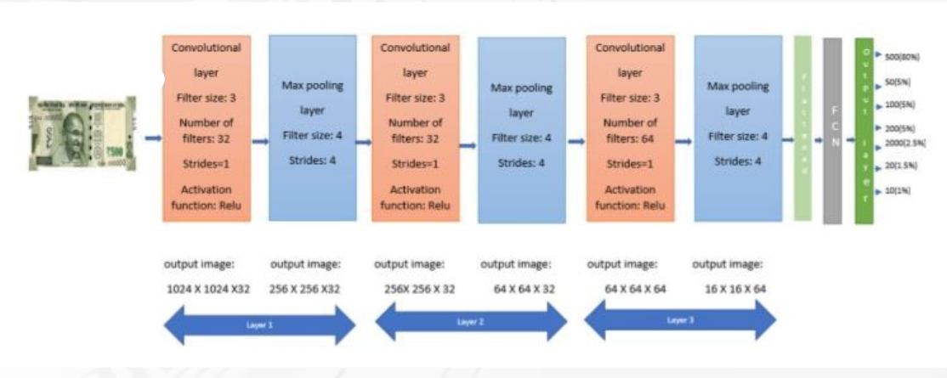

Fig 1.7.2 CNN Model Building

**1.12.2.1 Model Building on Indian Currency**

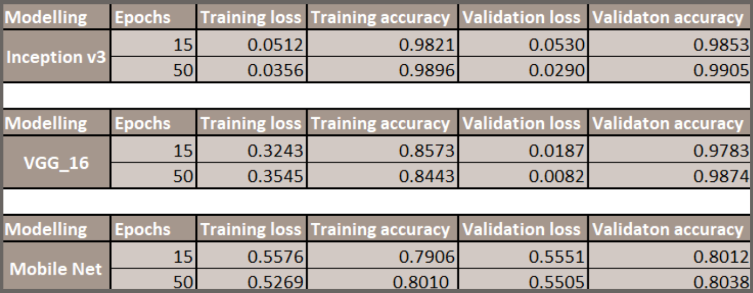

Table 1.7.2.1 Model Building on Indian Currency

* **Inception V3:** This model achieved the best validation accuracy of 99.05% after 50 epochs of training. This means that the model can correctly classify 99.05% of the images in the validation set after 50 training sessions. The training loss is 0.0356, which means that the model can learn the training data well. The validation loss is 0.0290, which means that the model can generalize well to unseen data.
* **VGG_16:** This model achieved a validation accuracy of 98.74% after 50 epochs of training. The training loss is 0.3545, and the validation loss is 0.0082. While the validation accuracy is lower than Inception V3, the validation loss is much lower, which suggests that this model may be able to generalize better to completely new data.
* **Mobile Net V2:** This model achieved a validation accuracy of 80.38% after 50 epochs of training. The training loss is 0.5269, and the validation loss is 0.5505. This model has the lowest accuracy and highest loss of the three models, which suggests that it may not be as effective at classifying Indian currency as the other two models.

**1.12.2.2 Model Building on Chinese Yuan/Renminbi**

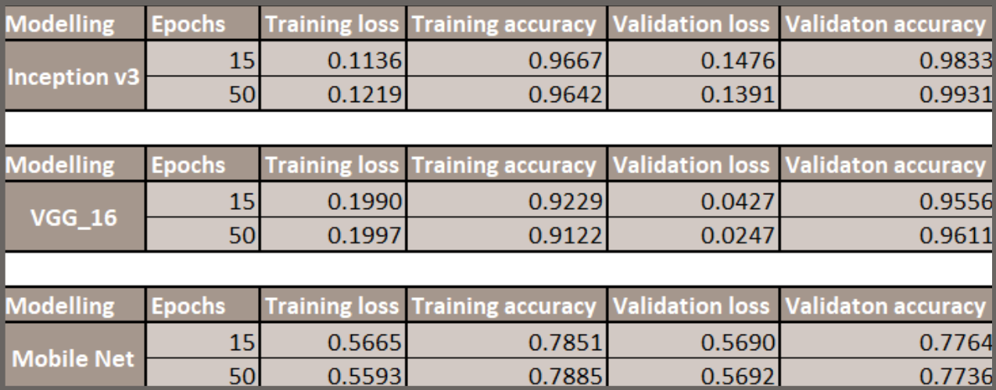

Table 1.7.2.2 Model Building on Chinese Yuan/Renminbi

* Each model, InceptionV3, VGG16, and MobileNet, demonstrated significant effectiveness in recognizing Chinese currency, showcasing their adaptability and versatility for the task.
* **Inception V3:** This model achieved the highest validation accuracy (99.31%) after 50 epochs of training. However, it also has the highest training loss (0.1219) after 50 epochs, which suggests that it may be overfitting the training data.
* **VGG_16:** This model achieved a validation accuracy of 96.11% after 50 epochs, which is lower than Inception v3 but still very good. It also has a lower training loss (0.1997) after 50 epochs, suggesting that it may be less prone to overfitting.
* **Mobile Net V2:** This model has the lowest validation accuracy (77.36%) after 50 epochs. It also has the highest training loss (0.5593) after 50 epochs, suggesting that it may not be learning the training data as well as the other two models.

**1.12.2.3 Model Building on US Dollars**

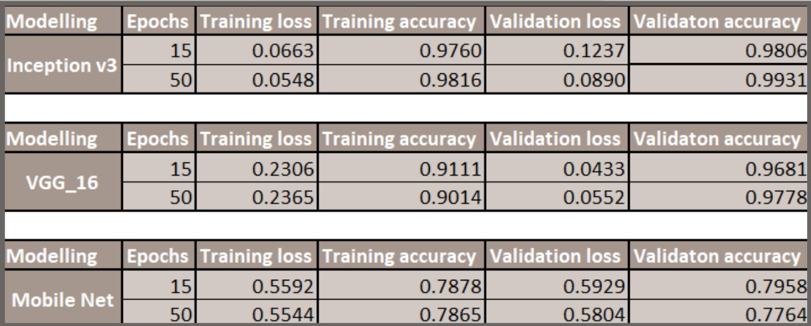

Table 1.7.2.2 Model Building on US Dollars

* **Inception V3:** This model achieved the best overall validation accuracy, at 99.31% after 50 epochs. Its training accuracy is also high, at 98.16% after 50 epochs. However, it also has the highest training loss, at 0.0548 after 50 epochs, and its validation loss is also relatively high, at 0.0890 after 50 epochs.
* **VGG 16:** This model has a slightly lower validation accuracy than Inception v3, at 97.78% after 50 epochs. Its training accuracy was also lower, at 90.14% after 50 epochs. However, it has a much lower training loss than Inception v3, at 0.2365 after 50 epochs, and its validation loss is also lower, at 0.0552 after 50 epochs.
* **Mobile Net V2:** This model has the lowest validation accuracy of the three models, at 77.64% after 50 epochs. However, it has the lowest training loss of the three models, at 0.5544 after 50 epochs, and its validation loss is also the lowest, at 0.5804 after 50 epochs. This suggests that Mobile Net may have been the least prone to overfitting of the three models, but it is also the least able to learn the task of classification.

**1.12.3 Model Conclusion**

* For the classification purpose deep learning models Inception V3, MobileNetV2 and VGG16 were evaluated. Inception V3 demonstrated the best overall performance among the three models as.
* It had lower training and validation loss and high Training and Validation accuracy which concludes that Inception V3 was successful in classifying the currencies in the training data as well as the validation data.
* This tells us that Inception V3 model was able to generalize and understand the patterns on the unseen data as well.
* Performance of MobileNetV2 and VGG16 did not surpass that of Inception V3 in the context of the specific currency classification task.

**1.13 ANDROID APPLICATION FOR CLASSIFICATION OF INDIAN DENOMINATION WITH VOICE OUTPUT**

**🡪 Introduction:**

The Android Application for Currency Classification with Voice Output is a mobile application developed to assist users, especially individuals with visual impairments, in identifying currency notes accurately. The application utilizes machine learning techniques to classify currency notes and provides voice feedback to convey the denomination to the user. Additionally, it includes a server-side component built with Flask, enabling communication between the Android application and the machine learning model.

* **Purpose and Significance:**

The primary purpose of the Android application is to empower visually impaired individuals by providing them with a tool to independently recognize and distinguish currency notes. By leveraging machine learning algorithms and voice output capabilities, the application enhances accessibility and promotes financial inclusivity for users with visual disabilities. This technology addresses a critical need for reliable currency identification solutions tailored to the specific requirements of visually impaired individuals.

* **Functionality:**

The Android Application for Currency Classification offers the following functionality:

* Image Upload: Users can capture an image of a currency note using the device's camera or select an existing image from the gallery.
* Currency Classification: The application analyzes the uploaded image using a pre-trained machine learning model to classify the currency note's denomination.
* Voice Output: Upon successful classification, the application verbally announces the denomination of the currency note to the user using synthesized speech.
* Server Communication: The Android application communicates with a Flask server hosted remotely to perform currency classification using the machine learning model.
* Postman Integration: Developers can test the application's functionality using Postman, a popular API development tool, to simulate image uploads and receive classification results.
* **Features:**

The Android Application for Currency Classification have the following features:

* Accessibility: Designed with accessibility in mind, the application provides a user-friendly interface and leverages voice output to cater to the needs of visually impaired users.
* Real-Time Classification: Currency classification is performed in real-time, enabling users to receive immediate feedback on the denomination of the currency note.
* Machine Learning Integration: The application integrates a machine learning model trained to recognize and classify various denominations of currency notes accurately.
* Server-Side Processing: Utilizing a Flask server, the application offloads the computational burden of currency classification, ensuring efficient processing and timely responses.
* Postman Testing: Developers can validate the application's functionality and API endpoints using Postman, streamlining the testing and debugging process.
* **How It Works:**

The Android Application for Currency Classification works in the following way:

* Image Capture: Users capture an image of a currency note using the device's camera or select an existing image from the gallery.
* Server Communication: The Android application sends the uploaded image to the Flask server for currency classification via a POST request.
* Currency Classification: The Flask server processes the received image using a pre-trained machine learning model (implemented in `detect.py`) to classify the currency note's denomination.
* Voice Feedback: Upon successful classification, the server sends the denomination information back to the Android application, which then utilizes synthesized speech to verbally announce the denomination to the user.
* Postman Testing: Developers can use Postman to simulate image uploads and test the application's API endpoints for accurate classification and response handling.
* **Use Case for Visually Impaired Users:**

The Android Application for Currency Classification helps the blind people in the following way:

* Independence: Visually impaired individuals can use the Android application independently to identify currency notes without relying on assistance from others.
* Accessibility: The voice output feature ensures accessibility by providing auditory feedback, enabling users with visual impairments to navigate and interact with the application effectively.
* Empowerment: By leveraging technology to overcome barriers associated with currency recognition, the application empowers visually impaired individuals to manage their finances with confidence and independence.
* **Server Architecture:**
* Flask Server: The Flask server acts as the backend for the Android application, receiving image uploads, performing currency classification using the machine learning model, and sending classification results back to the application.
* Communication Protocol: The Android application communicates with the Flask server via HTTP requests, utilizing RESTful API endpoints to facilitate data exchange.
* Scalability and Reliability: The server architecture is designed to be scalable and reliable, accommodating multiple concurrent requests from users and ensuring consistent performance under varying load conditions.

In conclusion, the Android Application for Currency Classification with Voice Output represents a significant advancement in accessibility technology, offering visually impaired individuals a practical solution for currency identification and financial independence. By combining machine learning, voice output, and server-side processing, the application provides an intuitive and inclusive user experience, empowering users to confidently manage their finances in a digital age.

# COUNTERFEIT DETECTION

# (FAKE v/s REAL DETECTION)

## 2.1 INTRODUCTION

The problem of detecting fake currency notes is crucial for maintaining the integrity of the economy. In recent years, there has been a surge in the use of deep learning models for detecting counterfeit currency using image processing. For Human being it is very difficult to identify fake currencies, So automatic systems for detection of fake currency is important. In this project, we propose a Convolutional Neural Network (CNN) model for detecting fake currency notes. To train our model, we use a dataset of images containing both genuine and fake currency notes of different denominations. The dataset is preprocessed by resizing all images to a fixed size and normalizing the pixel values. The pre-processed images are then split into training and validation sets for training and testing the model, respectively. This project is modelled as a CNN for automatic feature extraction and classification. The Experimental results validate that the proposed model effectively recognises a real and counterfeit currencies of various denominations with the confidence score

The outcome of this training process is then integrated into a mobile application, providing a user-friendly interface for real-time currency verification. Users can simply capture an image of a currency note using their mobile device, and the application will promptly analyze the features to determine its authenticity.

This project not only enhances the efficiency of currency verification but also serves as a proactive measure against fraudulent activities. The widespread adoption of this technology in financial institutions, retail businesses, and by individuals will contribute to a secure and trustworthy economic environment.

## 2.2 PROBLEM STATEMENT

* **Global Counterfeiting Challenge:**

Counterfeiting of currency notes is a pervasive issue worldwide, threatening the stability and trustworthiness of financial systems across countries and economies.

* **Manual Inspection Limitations:**

Traditional methods of counterfeit detection heavily rely on manual inspection, which is prone to human errors and subjectivit. This introduces inconsistencies and inefficiencies in the detection process.

* **Cost and Accessibility Concerns:**

Utilizing specialized equipment for counterfeit detection can be prohibitively expensive for many institutions and businesses. Moreover, such equipment may not be universally accessible, particularly in regions with limited resources.

* **Threat to Trust and Security:**

Counterfeiting not only poses a direct financial risk but also undermines the trust and security of monetary systems. Individuals and businesses may suffer losses, and overall economic stability can be compromised.

* **Complexity of Detection:**

Counterfeiters continually innovate to produce fake currency notes that closely resemble genuine ones, making detection increasingly challenging. This necessitates the development of advanced and sophisticated detection techniques.

## LITERATURE REVIEW

Several Techniques were proposed by various authors for Currency Identification, Forged Banknote Detection. In this scenario, a brief evaluation of some important contributors to existing literature is presented shortly.

* **Gouri Sanjay et al. (2018),** The counterfeiters are becoming harder to track down because of their use of highly advanced technology. One of the most effective methods to stop counterfeiting can be the use of counterfeit detection software that is easily available and is efficient. Our project will recognize Indian currency notes using a real-time image obtained from a webcam. The background of our topic is image processing technology and applying it for the purpose of verifying valid currency notes. The software will detect fake currency by extracting features of notes. The success rate of this software can be measured in terms of accuracy and speed. Main aim is to work on those parameters which will be impossible to implement on counterfeit notes so we considered working on minutiae parameters which will be enough to differentiate between fake and original notes.
* **Shital Mahajan et al. (2018),** Surveys paper reports various articles dealing with counterfeit paper currency recognition and detection systems which attempts to represent the survey on fake money detection because almost every country in the world is facing the problem of forged money, but in India, the problem is exasperating as the country is hit hard by this evil practices. There has been no prior survey on the currency identification methodologies and the comprehensive survey presented in this paper will be useful in developing and analyzing new approaches and algorithms with good performance.

## 2.4 USE CASES

* **Financial Institutions:** Banks and other financial entities can integrate the system into their currency handling processes, reducing the risk of accepting counterfeit currency and fortifying the overall security of transactions.
* **Retail Businesses:** Retailers can utilize the system to verify the authenticity of currency notes during transactions. This safeguards their revenue and prevents losses associated with accepting fake currency.
* **Individuals:** The mobile application developed as part of this project can be used by individuals for personal transactions. It empowers them to quickly verify the legitimacy of currency notes, promoting confidence in day-to-day financial interactions.

## 2.5 BENEFITS

* **Preservation of Economic Stability:** Fake currency detection helps in maintaining the stability of the economy by preventing the circulation of counterfeit money. Counterfeits can disrupt the monetary system, leading to inflation and loss of confidence in the currency.
* **Protection of Financial Institutions:** Banks, businesses, and other financial institutions are protected from financial losses that may arise from accepting counterfeit currency. Detection measures help these institutions identify and reject fake money, minimizing potential losses.
* **Prevention of Illegal Activities:** Counterfeit currency is often used to finance illegal activities such as drug trafficking, terrorism, and money laundering. Effective detection helps in curbing such illicit activities by disrupting their financial support systems.

## 2.6 OBJECTIVE

The objective of using deep learning for fake currency detection is to develop a reliable system capable of automatically identifying counterfeit currency notes from genuine ones. In this approach, deep learning algorithms, particularly Convolutional Neural Networks (CNNs), are trained on a dataset containing images of both real and fake currency notes. The goal is to teach the model to recognize patterns and features that distinguish genuine currency from counterfeit versions.

By leveraging deep learning techniques, the system aims to achieve high accuracy and efficiency in detecting fake currency, thus reducing the risk of financial losses and maintaining the integrity of monetary transactions. This technology offers several advantages over traditional methods of currency authentication, such as manual inspection or the use of specialized equipment, by providing a scalable and automated solution.

The ultimate aim is to deploy this deep learning-based fake currency detection system across various sectors, including banks, businesses, and government agencies, to enhance security and protect against financial fraud. By integrating such systems into existing infrastructure, organizations can streamline the process of currency verification, minimize the circulation of counterfeit money, and safeguard the economy.

## 2.7 OVERALL SYSTEM ARCHITECTURE OF FAKE CURRENCY DETECTION

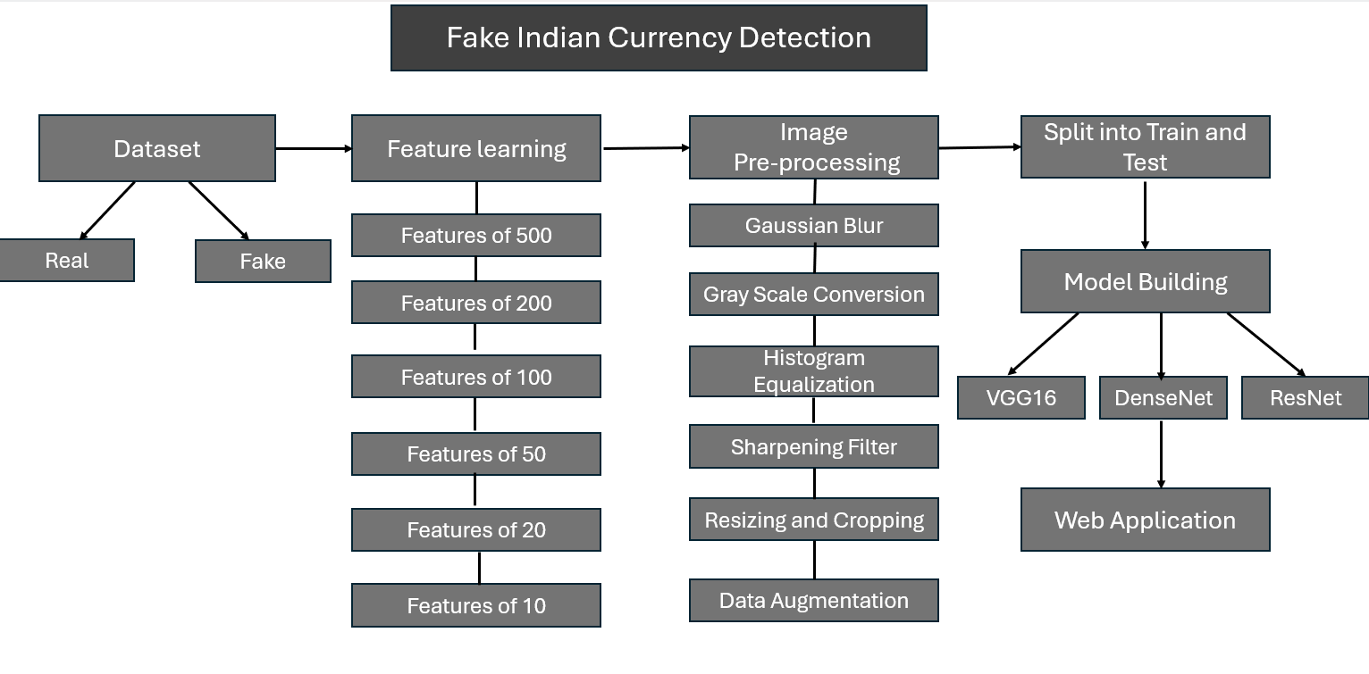

Fig. 2.8 Overall Architecture of Fake Currency Detection

**2.8 DATASET**

* The entire dataset was collected through different sites like Google.
* The dataset comprises of images of both real and fake currency notes of denominations 10, 20, 50, 100, 200 and 500 Indian rupee.
* Initially, the dataset collected had 50 images of each denomination for both fake and real, after applying data augmentation technique to increase the number of images for both real and fake currencies
* The dataset consists of a total of 5983 images, divided into training and testing datasets. The training dataset has 4184 images, with 2096 images of real currency and 2088 images of fake currency. Similarly, the testing dataset has 1799 images, with 899 images of real currency and 900 images of fake currency.

**2.9 PREPROCESSING STEPS FOR FAKE CURRENCY DETECTION**

**Image Preprocessing:**

1. **Gaussian Blur:** Applied to reduce noise and smoothen the images, making it easier for the model to extract features and patterns. Noise reduction is essential for improving the model's accuracy in distinguishing between real and fake currency notes.
2. **Grayscale Conversion:** Convert images to grayscale to simplify data and reduce computational complexity. Grayscale images contain only intensity information, which is often sufficient for currency detection tasks, reducing the input dimensionality for the model.
3. **Histogram Equalization:** Histogram equalization stretches the contrast in your image, making details like security threads and watermarks pop out. This helps the deep learning model see these features better for fake currency detection. It works by redistributing pixel intensities across the image, creating a more balanced distribution.
4. **Sharpening Filter:** Applied to enhance edges and details in the images, improving feature extraction. Sharpening enhances the contrast between different regions of the currency notes, making it easier for the model to identify distinguishing features.
5. **Resizing and Cropping:** Images are resized to a standard dimension and cropped to focus on the currency area, removing unnecessary background. Standardizing the image size ensures consistency in input dimensions for the model, while cropping removes irrelevant information, reducing noise and improving model performance.

**Data Augmentation:**

**Duplication:** Each image is replicated multiple times to increase the dataset size and balance the distribution of real and fake currency images. Data augmentation helps mitigate overfitting and improves the model's generalization ability by providing more diverse training examples.

* Import Libraries: The script imports necessary libraries including OpenCV (cv2), os, and numpy.
* Define Input Paths: The paths to the folders containing real and fake 500, 200, 100, 50, 20, 10 Rupees currency notes images are defined using real_folder and fake_folder variables, respectively.
* Image Preprocessing Function: The preprocess_image function is defined to preprocess each image. It resizes the image, applies Gaussian blur for noise reduction, converts it to grayscale, and then applies a sharpening filter.
* Create Output Directories: The script creates output directories (output_real_folder and output_fake_folder) to store preprocessed images. If these directories don't exist, they are created using os.makedirs.
* Preprocess Real Images: The script iterates over each image in the real folder, loads it using OpenCV, preprocesses it using the preprocess_image function, and saves the preprocessed image to the output directory.
* Preprocess Fake Images: Similar to real images, the script iterates over each image in the fake folder, preprocesses it, and saves the preprocessed image to the output directory.
* Print Status: The script prints a message indicating that preprocessing is completed once all images have been processed.

**2.10 MODEL CREATION, TRAINING & TESTING**

There were 3 CNN models evaluated that is Resnet50, Dense net and VGG16

**2.12.1 Evaluated CNN Architectures**

**🡪 Resnet50:**

* ResNet50 is a convolutional neural network architecture developed by Microsoft Research.
* It consists of 50 layers deep neural network that utilizes skip connections to address the vanishing gradient problem, which allows for easier training of very deep networks.

**Key Features:**

* Skip connections: These connections allow gradients to flow more directly during backpropagation, which helps in training deeper networks without suffering from degradation problems.
* Deep architecture: With 50 layers, ResNet50 captures intricate features at various levels of abstraction, which is crucial for complex image recognition tasks.

**Working:**

* ResNet50 processes input images by passing them through multiple convolutional layers, each layer extracting different features from the input.
* The skip connections ensure that deeper layers have access to features from shallower layers, making it easier to learn and retain relevant information.
* Through a combination of convolutional layers, pooling layers, and non-linear activation functions like ReLU, ResNet50 learns to classify images into different categories based on the learned features.

**Relevance to Fake Currency Detection:**

* The deep architecture of ResNet50 allows it to capture intricate patterns and features present in currency notes, which might be crucial for distinguishing between real and fake currency.
* The skip connections help in learning features that might be present across different denominations or variations of counterfeit currency notes, ensuring robustness in detection.

**🡪 Densenet:**

* DenseNet, short for Dense Convolutional Network, is a CNN architecture introduced by researchers at Facebook AI Research.
* It is characterized by its densely connected layers, where each layer is connected to every other layer in a feed-forward fashion.

**Key Features:**

* Dense connectivity: Each layer receives feature maps from all preceding layers and passes its own feature maps to all subsequent layers.
* Feature reuse: Dense connectivity encourages feature reuse, allowing the network to maintain a very compact and efficient representation of features.
* Alleviates vanishing gradient: By promoting direct connections between layers, Dense Net mitigates the vanishing gradient problem, facilitating easier training of very deep networks.

**Working:**

* Dense Net's dense connectivity allows for efficient feature propagation throughout the network, ensuring that each layer receives feature maps from all preceding layers.
* During training, feature maps are concatenated across channels, resulting in dense feature representations that capture intricate patterns and details from the input image.
* This dense feature propagation enables effective gradient flow during backpropagation, facilitating the training of very deep networks.

**Relevance to Fake Currency Detection:**

* The dense connectivity of Dense Net enables it to capture fine-grained details and subtle differences between real and fake currency notes.
* By allowing feature reuse, Dense Net can efficiently leverage relevant information from different parts of the currency note, aiding in accurate classification.

**🡪 VGG16:**

* VGG16 is a convolutional neural network architecture developed by the Visual Graphics Group (VGG) at the University of Oxford.
* It consists of 16 layers with mostly 3x3 convolutional filters, with max-pooling layers interspersed throughout the network.

**Key Features:**

* Simplicity and uniformity: VGG16 architecture is characterized by its simplicity and uniformity, with stacks of convolutional layers followed by max-pooling layers.
* Deep representation: Despite its simplicity, VGG16 can capture complex hierarchical features due to its depth and use of small convolutional filters.
* Transfer learning: VGG16 is widely used for transfer learning due to its pre-trained weights on large datasets like ImageNet.

**Working:**

* VGG16 processes input images by passing them through a series of convolutional layers, each layer extracting different features from the input.
* Max-pooling layers reduce the spatial dimensions of the feature maps, allowing the network to focus on the most relevant information while discarding spatial redundancies.
* The extracted features are then flattened and passed through fully connected layers followed by SoftMax activation for classification.

**Relevance to Fake Currency Detection:**

* VGG16's ability to capture hierarchical features makes it suitable for detecting patterns and distinguishing characteristics present in currency notes.
* Its pre-trained weights on ImageNet can be leveraged through transfer learning, allowing for faster convergence and potentially better generalization to the task of fake currency detection.

**Model Building and evaluation of Indian Currency**

**🡪 Resnet50: First Cut Model**

**Hyper Parameters used:**

* Learning Rate (lr):
  + lr=1e-4 sets the learning rate to 0.0001.
* Batch Size:
  + batch size = 32 here means 32 images will be processed at once before updating the model's parameters.
  + Image Data Generator is used for data augmentation, including rescaling, shear range, zoom range, and horizontal flip.
* Optimizer:
  + The Adam optimizer is used with the specified learning rate for model compilation.
  + Adam optimizer adapts the learning rate during training.
* Loss Function:
  + Binary cross-entropy loss function is used for model compilation.
  + Binary cross-entropy is suitable for binary classification problems like fake currency detection.
* Model Architecture:
  + The base model is ResNet50 pre-trained on ImageNet data.
  + The last fully connected layer is removed (include top=False), and additional layers are added for custom classification.
  + Added layers include flattening, dense layer with ReLU activation, dropout, and a final dense layer with sigmoid activation for binary classification.
* Callbacks:
  + Model Checkpoint is set up to save the best model based on validation accuracy during training.
* Epochs:
  + Model is being trained for 10 epochs.

**Model Evaluation**

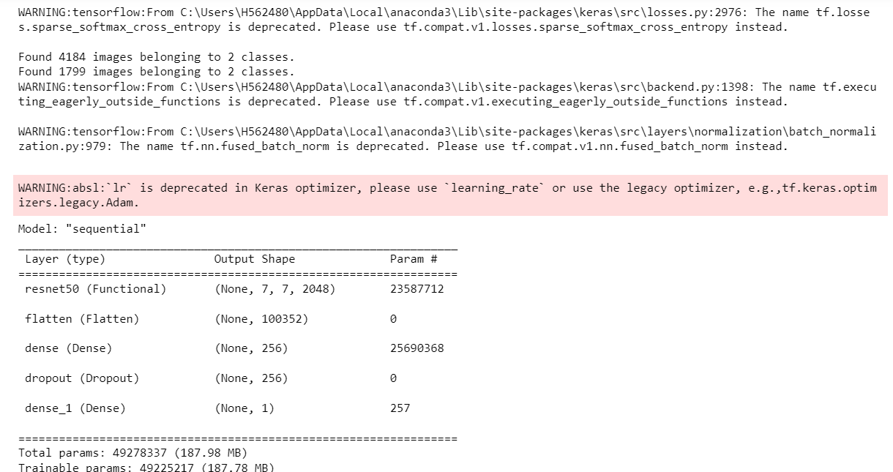

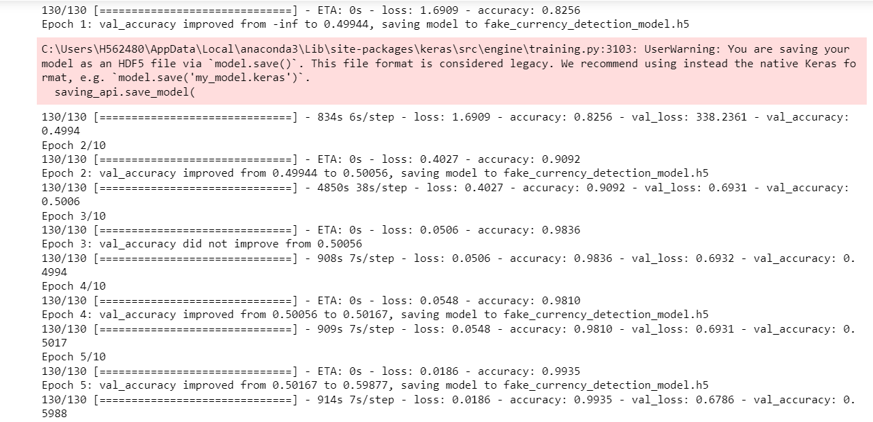

This goes on up to 10Epochs.

**Train set:**

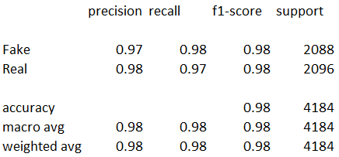

* Precision:
  + Precision for the "Fake" class is 0.97, indicating that 97% of the instances predicted as fake were actually fake.
  + Precision for the "Real" class is 0.98, suggesting that 98% of the instances predicted as real were actually real.
* Recall:
  + Recall for the "Fake" class is 0.98, meaning that 98% of the actual fake instances were correctly predicted as fake.
  + Recall for the "Real" class is 0.97, indicating that 97% of the actual real instances were correctly predicted as real.
* F1-score:
  + F1-score for the "Fake" class is 0.98, representing the harmonic mean of precision and recall for the fake class.
  + F1-score for the "Real" class is 0.98, suggesting the balance between precision and recall for the real class.
* Accuracy:
  + The overall accuracy on the training set is 98%, implying that the model correctly classified 98% of the instances.

**Test Set:**

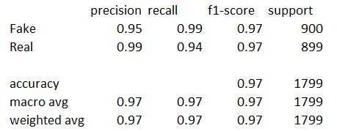

* Precision:
  + Precision for the "Fake" class is 0.95, indicating that 95% of the instances predicted as fake were actually fake.
  + Precision for the "Real" class is 0.99, suggesting that 99% of the instances predicted as real were actually real.
* Recall:
  + Recall for the "Fake" class is 0.99, meaning that 99% of the actual fake instances were correctly predicted as fake.
  + Recall for the "Real" class is 0.94, indicating that 94% of the actual real instances were correctly predicted as real.
* F1-score:
  + F1-score for the "Fake" class is 0.97, representing the harmonic mean of precision and recall for the fake class.
  + F1-score for the "Real" class is 0.97, suggesting the balance between precision and recall for the real class.
* Accuracy:
  + The overall accuracy on the test set is 97%, indicating that the model correctly classified 97% of the instances.

**Interpretation:**

* The model demonstrates excellent performance on both the training and test sets, with high precision, recall, and F1-scores for both classes.
* There is a slight decrease in performance on the test set compared to the training set, which is expected due to the unseen nature of the test data.
* The model shows robustness in distinguishing between fake and real currency notes, as evidenced by the high accuracy and balanced performance metrics for both classes.

**🡪 Resnet50: Second Cut Model**

**Hyper Parameters Used:**

* Batch Size:
  + Here, batch size = 32 implies that 32 images are processed in each training iteration.
* Optimizer:
  + The specified learning rate (lr=1e-4) is used for the Adam optimizer.
* Callbacks:
  + - Model Checkpoint: Saves the best model based on validation accuracy.
    - Early Stopping: Stops training if validation loss doesn't improve after a certain number of epochs, preventing overfitting.
    - The patience for early stopping is set to patience=3, meaning training will stop after 3 epochs without improvement in validation loss.
* Epochs:
  + Epochs have been increased to 20.

**Model Evaluation:**

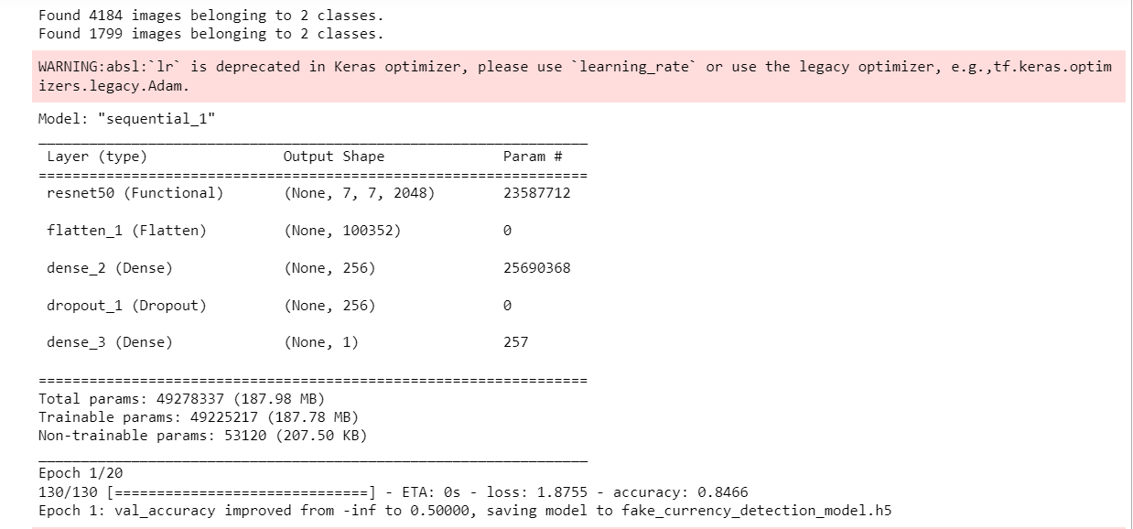

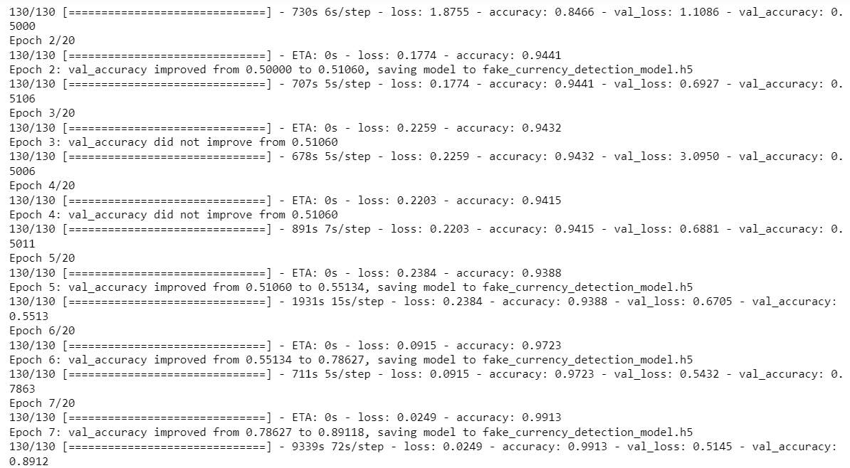

This goes on up to 20 Epochs.

**Train set:**

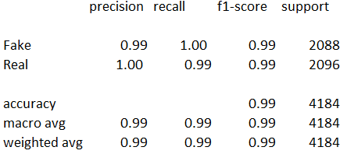

* Precision:
  + Precision for the "Fake" class is 0.99, indicating that 99% of the instances predicted as fake were actually fake.
  + Precision for the "Real" class is 1.00, suggesting that all instances predicted as real were actually real.
* Recall:
  + Recall for the "Fake" class is 1.00, meaning that all actual fake instances were correctly predicted as fake.
  + Recall for the "Real" class is 0.99, indicating that 99% of the actual real instances were correctly predicted as real.
* F1-score:
  + F1-score for the "Fake" class is 0.99, representing the harmonic mean of precision and recall for the fake class.
  + F1-score for the "Real" class is 0.99, indicating the balance between precision and recall for the real class.
* Accuracy:
  + The overall accuracy on the training set is 99%, implying that the model correctly classified 99% of the instances.

**Test Set:**

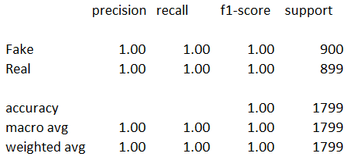

* Precision:
  + Precision for both classes ("Fake" and "Real") is 1.00, indicating perfect precision where all predictions are correct.
* Recall:
  + Recall for both classes ("Fake" and "Real") is 1.00, meaning that all actual instances were correctly predicted.
* F1-score:
  + F1-score for both classes ("Fake" and "Real") is 1.00, suggesting perfect balance between precision and recall.
* Accuracy:
  + The overall accuracy on the test set is 100%, indicating that the model correctly classified all instances in the test set.

**Interpretation:**

* The model demonstrates exceptional performance on both the training and test sets, with high precision, recall, F1-score, and accuracy.
* On the training set, the model achieves near-perfect performance, with very high scores across all metrics.
* On the test set, the model achieves performance, with all metrics (precision, recall, F1-score, and accuracy) equal to 1.00.
* There is overfitting because the model will not be able to generalize well on unseen data.

**🡪 Dense net: First Cut Model**

**Hyper Parameters Used:**

* Learning Rate (lr):
  + Hyperparameter lr=1e-4 sets the learning rate to 0.0001.
* Batch Size:
  + Batch size defines the number of samples processed before the model is updated.
  + batch size = 32 here means 32 images will be processed at once before updating the model's parameters.
* Number of Epochs:
  + epochs=10 specifies that the model will be trained for 10 complete passes through the training dataset.
* Optimizer:
  + Optimizers are algorithms or methods used to change the attributes of the neural network such as weights and learning rate to reduce the losses.
  + Adam optimizer is used here with a learning rate of 1e-4.
* Loss Function:
  + The loss function computes the error between predicted and true values during training.
  + binary_crossentropy is the loss function used here as it is suitable for binary classification problems.
* Data Augmentation:
  + Data augmentation is a technique used to increase the diversity of the training set by applying random transformations.
  + Image Data Generator is used for data augmentation, which includes rescaling, shear range, zoom range, and horizontal flip.
* Dropout Rate:
  + Dropout is a regularization technique used to prevent overfitting.
  + layers. Dropout (0.5) applies dropout with a rate of 0.5, meaning half of the neurons will be randomly dropped out during training.
* Model Architecture:
  + The model architecture is based on DenseNet121, a pre-trained convolutional neural network architecture.
  + The final layers added include global average pooling, fully connected layers with ReLU activation, dropout, and a sigmoid output layer.
* Callbacks:
  + Callbacks are functions that can be applied at certain stages of the training process.
  + Model Check point is used to save the best model based on validation accuracy.

These hyperparameters collectively influence the training process of the model and impact its performance in distinguishing between real and fake currency notes.

**Model Evaluation**

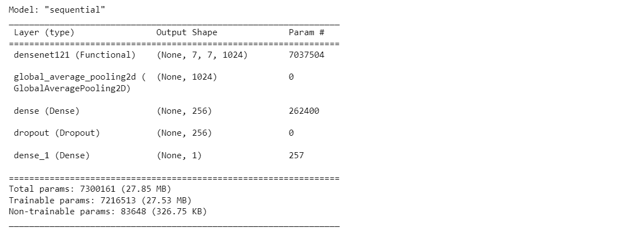

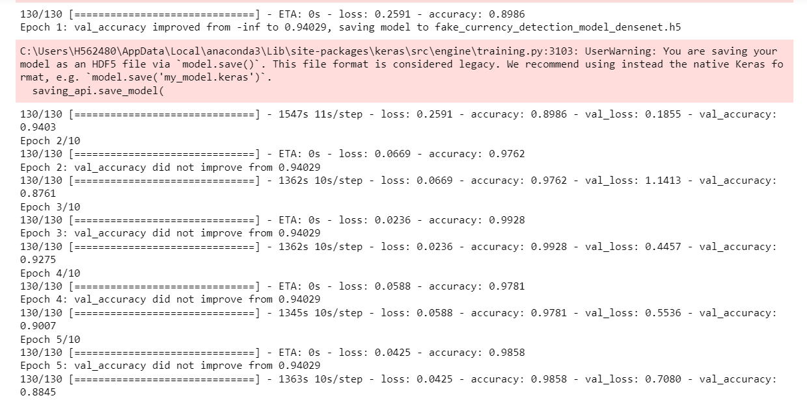

This goes on up to 10 epochs.

**Training Set:**

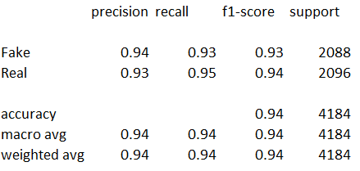

* Precision:
  + Precision for the "Fake" class is 0.94, meaning that out of all the instances predicted as fake, 94% were actually fake.
  + Precision for the "Real" class is 0.93, indicating that out of all the instances predicted as real, 93% were actually real.
* Recall:
  + Recall for the "Fake" class is 0.93, suggesting that 93% of the actual fake instances were correctly predicted as fake.
  + Recall for the "Real" class is 0.95, indicating that 95% of the actual real instances were correctly predicted as real.
* F1-score:
  + F1-score for the "Fake" class is 0.93, which is the harmonic mean of precision and recall for the fake class.
  + F1-score for the "Real" class is 0.94, indicating the balance between precision and recall for the real class
* Accuracy:
  + The overall accuracy on the training set is 94%, suggesting that the model correctly classified 94% of the instances.

**Test Set:**

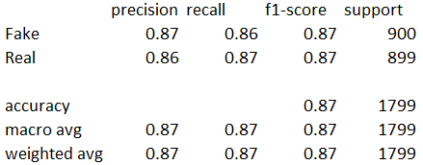

* Precision:
  + Precision for the "Fake" class is 0.87, indicating that out of all the instances predicted as fake, 87% were actually fake.
  + Precision for the "Real" class is 0.86, suggesting that out of all the instances predicted as real, 86% were actually real.
* Recall:
  + Recall for the "Fake" class is 0.86, meaning that 86% of the actual fake instances were correctly predicted as fake.
  + Recall for the "Real" class is 0.87, indicating that 87% of the actual real instances were correctly predicted as real.
* F1-score:
  + F1-score for the "Fake" class is 0.87, which is the harmonic mean of precision and recall for the fake class.
  + F1-score for the "Real" class is 0.87, suggesting the balance between precision and recall for the real class.
* Accuracy:
  + The overall accuracy on the test set is 87%, meaning that the model correctly classified 87% of the instances in the test set.

**🡪 Densenet50: Second Cut Model**

**Hyper Parameters used:**

* Dropout Rates:
  + Two dropout rates are used: 0.3 and 0.5.
* Learning Rates:
  + Two learning rates are used: 1e-4 and 1e-5.
* Number of Epochs:
  + In the hyperparameter tuning loop, the model is trained for 15 epochs.
* Optimizer:
  + Adam optimizer with the specified learning rate is used for model compilation.
* Loss Function:
  + Binary cross-entropy loss function is used for model compilation.
* Callbacks:

Three callbacks are employed during training:

* + - Model Check point: Saves the best model based on validation accuracy.
    - Early Stopping: Stops training if validation loss doesn't improve after a certain number of epochs.
    - ReduceLROnPlateau: Reduces learning rate if validation loss plateaus.

**Model Evaluation**

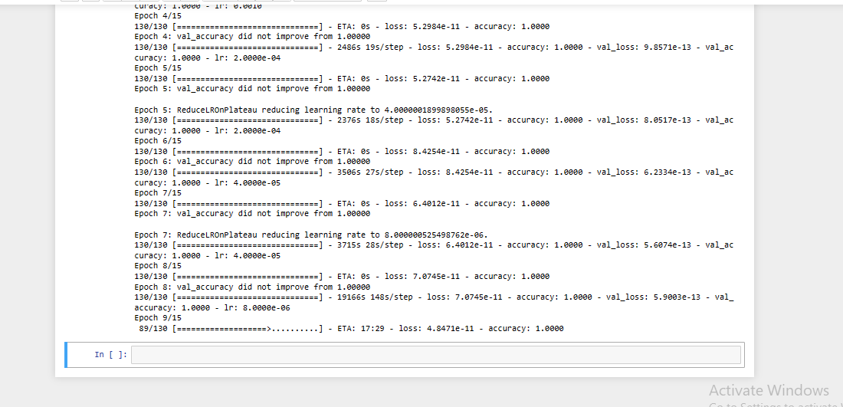

**This goes on up to 15 epochs.**

**Train Set:**

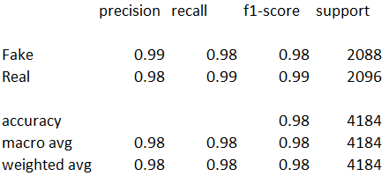

* Precision:
  + Precision for the "Fake" class is 0.99, meaning that out of all the instances predicted as fake, 99% were actually fake.
  + Precision for the "Real" class is 0.98, indicating that out of all the instances predicted as real, 98% were actually real.
* Recall:
  + Recall for the "Fake" class is 0.98, suggesting that 98% of the actual fake instances were correctly predicted as fake.
  + Recall for the "Real" class is 0.99, indicating that 99% of the actual real instances were correctly predicted as real.
* F1-score:
  + F1-score for the "Fake" class is 0.98, which is the harmonic mean of precision and recall for the fake class.
  + F1-score for the "Real" class is 0.99, indicating the balance between precision and recall for the real class.
* Accuracy:
  + The overall accuracy on the training set is 98%, suggesting that the model correctly classified 98% of the instances.

**Test Set:**

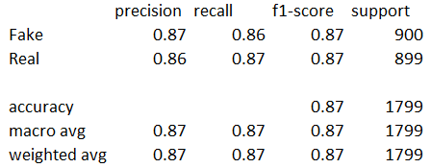

* Precision:
  + Precision for the "Fake" class is 0.87, indicating that out of all the instances predicted as fake, 87% were actually fake.
  + Precision for the "Real" class is 0.86, suggesting that out of all the instances predicted as real, 86% were actually real.
* Recall:
  + Recall for the "Fake" class is 0.86, meaning that 86% of the actual fake instances were correctly predicted as fake.
  + Recall for the "Real" class is 0.87, indicating that 87% of the actual real instances were correctly predicted as real.
* F1-score:
  + F1-score for the "Fake" class is 0.87, which is the harmonic mean of precision and recall for the fake class.
  + F1-score for the "Real" class is 0.87, suggesting the balance between precision and recall for the real class.
* Accuracy:
  + The overall accuracy on the test set is 87%, meaning that the model correctly classified 87% of the instances in the test set.

**Interpretation:**

* The model performs exceptionally well on the training set with high precision, recall, and F1-scores for both classes.
* However, the performance on the test set is slightly lower, with comparable precision, recall, and F1-scores but a lower overall accuracy.
* There might be some overfitting occurring as the model's performance on the training set significantly exceeds its performance on the unseen test data.

**🡪 VGG_16: First Cut Model**

**Hyper Parameters Used:**

* Learning Rate (lr):
  + The learning rate is set to lr=1e-4, indicating a learning rate of 0.0001.
* Batch Size:
  + Here, batch size = 32 implies that 32 images are processed in each training iteration.
* Data Augmentation:
  + Techniques such as rescaling, shear range, zoom range, and horizontal flip are applied using ImageDataGenerator.
* Optimizer:
  + The Adam optimizer is utilized for model compilation.
  + The specified learning rate (lr=1e-4) is used for the Adam optimizer.
* Loss Function:
  + Binary cross-entropy loss function is employed for model compilation.
  + Binary cross-entropy is suitable for binary classification problems like fake currency detection.
* Model Architecture:
  + The last fully connected layer is removed (include top=False), and additional layers are added for custom classification.

Added layers include flattening, dense layer with ReLU activation, dropout, and a final dense layer with sigmoid activation for binary classification.

* Number of Epochs:
  + The model is trained for epochs=10 iterations over the entire training dataset.

These hyperparameters control various aspects of model training, including optimization, regularization, and model architecture. They are essential for achieving good performance and generalization ability of the model.

**Model Evaluation**

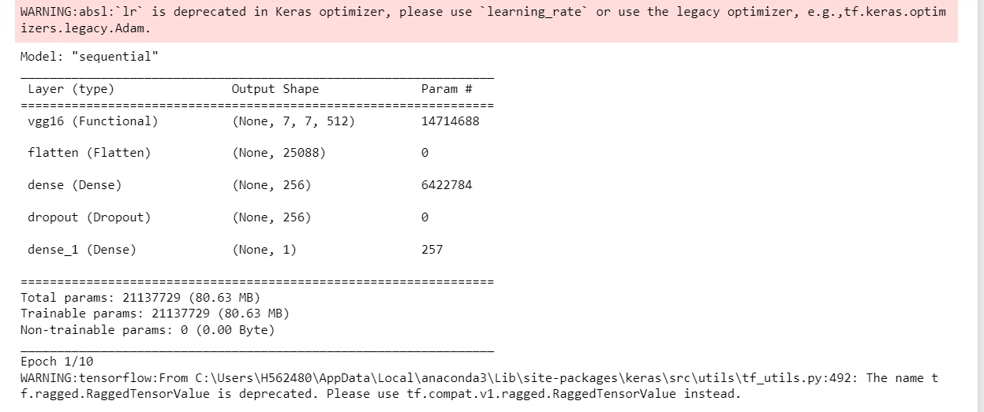

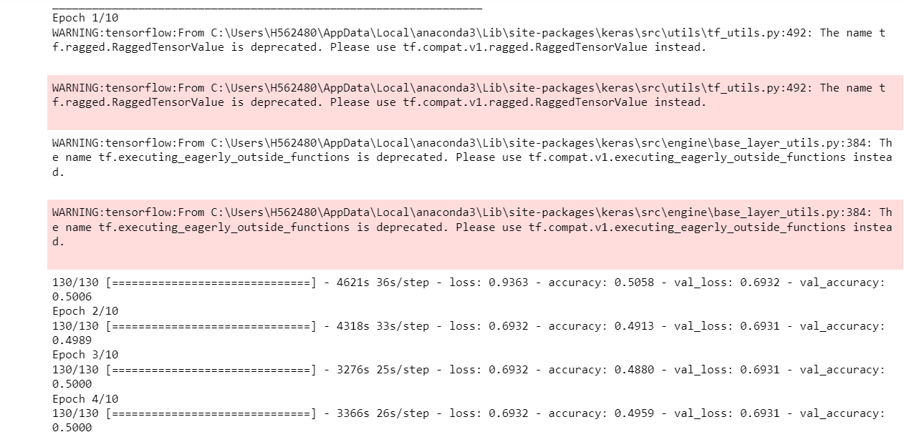

**This goes on for 10 epochs.**

**Train set:**

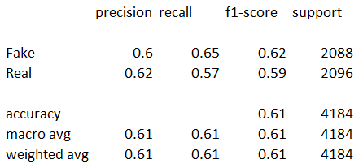

* Precision:
  + Precision for the "Fake" class is 0.60, indicating that 60% of the instances predicted as fake were actually fake.
  + Precision for the "Real" class is 0.62, suggesting that 62% of the instances predicted as real were actually real.
* Recall:
  + Recall for the "Fake" class is 0.65, meaning that 65% of the actual fake instances were correctly predicted as fake.
  + Recall for the "Real" class is 0.57, indicating that 57% of the actual real instances were correctly predicted as real.
* F1-score:
  + F1-score for the "Fake" class is 0.62, representing the harmonic mean of precision and recall for the fake class.
  + F1-score for the "Real" class is 0.59, indicating the balance between precision and recall for the real class.
* Accuracy:
  + The overall accuracy on the training set is 61%, implying that the model correctly classified 61% of the instances.

**Test Set:**

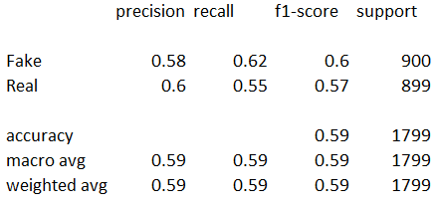

* Precision:
  + Precision for the "Fake" class is 0.58, indicating that 58% of the instances predicted as fake were actually fake.
  + Precision for the "Real" class is 0.60, suggesting that 60% of the instances predicted as real were actually real.
* Recall:
  + Recall for the "Fake" class is 0.62, meaning that 62% of the actual fake instances were correctly predicted as fake.
  + Recall for the "Real" class is 0.55, indicating that 55% of the actual real instances were correctly predicted as real.
* F1-score:
  + F1-score for the "Fake" class is 0.60, representing the harmonic mean of precision and recall for the fake class.
  + F1-score for the "Real" class is 0.57, indicating the balance between precision and recall for the real class.
* Accuracy:
  + The overall accuracy on the test set is 59%, implying that the model correctly classified 59% of the instances.

**Interpretation:**

* The model's performance on both the training and test sets is mediocre, with an accuracy of around 61% on the training set and 59% on the test set.
* Precision, recall, and F1-score for both classes ("Fake" and "Real") are relatively low, indicating that the model struggles to effectively differentiate between fake and real currency notes.
* The model appears to have difficulty in correctly identifying both fake and real instances, as evidenced by the lower recall scores.

**🡪 VGG_16: Second Cut Model**

**Hyper Parameters Used:**

* Learning Rate (lr):
  + The learning rate is set to lr=1e-5
* Batch Size:
  + Here, batch size = 32 implies that 32 images are processed
* Optimizer:
  + The Adam optimizer is utilized for model compilation.
  + The specified learning rate (lr=1e-5) is used for the Adam optimizer.
* Model Architecture:
  + The base model is VGG-16 pre-trained on the ImageNet dataset.
  + The last fully connected layer is removed (include top=False), and additional layers are added for custom classification.
* Number of Epochs:
  + The model is trained for epochs=20 iterations over the entire training dataset.

This model performs hyperparameter tuning using Grid Search CV to find the best combination of optimizer and dropout rate.

**Model Evaluation**

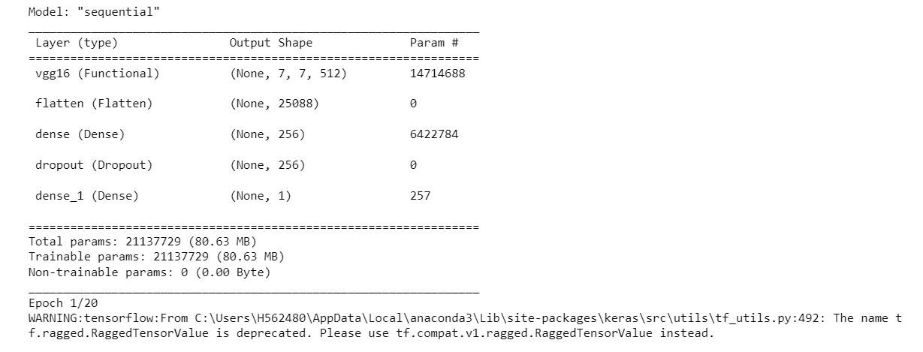

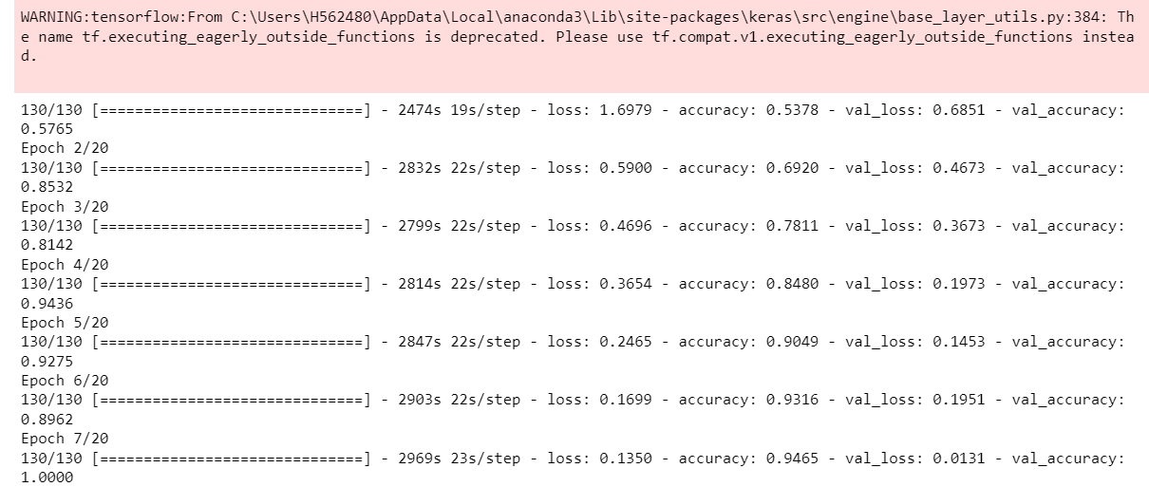

**This goes on up to 20 epochs.**

**Train Set:**

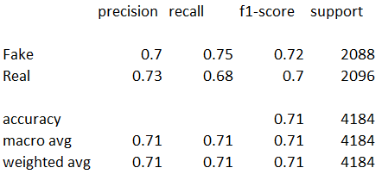

* Precision:
  + Precision for the "Fake" class is 0.70, indicating that 70% of the instances predicted as fake were actually fake.
  + Precision for the "Real" class is 0.73, suggesting that 73% of the instances predicted as real were actually real.
* Recall:
  + Recall for the "Fake" class is 0.75, meaning that 75% of the actual fake instances were correctly predicted as fake.
  + Recall for the "Real" class is 0.68, indicating that 68% of the actual real instances were correctly predicted as real.
* F1-score:
  + F1-score for the "Fake" class is 0.72, representing the harmonic mean of precision and recall for the fake class.
  + F1-score for the "Real" class is 0.70, indicating the balance between precision and recall for the real class.
* Accuracy:
  + The overall accuracy on the training set is 71%, implying that the model correctly classified 71% of the instances.

**Test Set:**

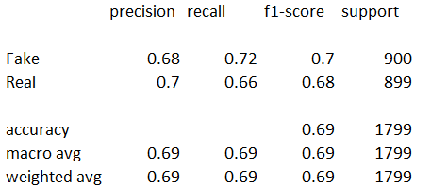

* Precision:
  + Precision for the "Fake" class is 0.68, indicating that 68% of the instances predicted as fake were actually fake.
  + Precision for the "Real" class is 0.70, suggesting that 70% of the instances predicted as real were actually real.
* Recall:
  + Recall for the "Fake" class is 0.72, meaning that 72% of the actual fake instances were correctly predicted as fake.
  + Recall for the "Real" class is 0.66, indicating that 66% of the actual real instances were correctly predicted as real.
* F1-score:
  + F1-score for the "Fake" class is 0.70, representing the harmonic mean of precision and recall for the fake class.
  + F1-score for the "Real" class is 0.68, indicating the balance between precision and recall for the real class.
* Accuracy:
  + The overall accuracy on the test set is 69%, implying that the model correctly classified 69% of the instances.

**Interpretation:**

* The model's performance on both the training and test sets is moderate, with an accuracy of around 71% on the training set and 69% on the test set.
* Precision, recall, and F1-score for both classes ("Fake" and "Real") are relatively balanced, indicating a fair ability to discriminate between fake and real currency notes.
* The model shows a slightly better performance on the training set compared to the test set, suggesting some level of generalization capability.
* Overall, the model's performance is reasonable but may not be optimal, depending on the specific requirements and context of the application. It does not seem to be overperforming or underperforming significantly.

**Conclusion**

* After evaluating multiple models for fake currency detection, it is evident that Res Net_50 trained for 10 epochs (First Cut model) stands out as the top performer with consistently higher accuracy and robustness compared to Dense Net and VGG16.
* Res Net emerges as the optimal choice for deployment in the web application.
* Its superior performance assures reliable and accurate detection of fake currency notes, ensuring the effectiveness and credibility of the application.

**Top of Form**

**2.13 FAKE CURRENCY NOTE DETECTOR APPLICATION**

* **Introduction:**

The Fake Currency Note Detector is a web application developed using Streamlit, a popular Python library for creating interactive web applications. This application aims to detect whether a currency note uploaded by the user is real or fake using a pre-trained machine learning model. The detection process is based on analyzing the image of the currency note provided by the user.

* **Purpose and Significance:**

Counterfeit currency poses a significant threat to the integrity of financial systems, leading to economic instability and financial losses. This application serves as a tool to help individuals and businesses verify the authenticity of currency notes, thereby reducing the risk of falling victim to counterfeit scams. By leveraging machine learning algorithms, the application provides a quick and reliable method for detecting fake currency notes.

* **Functionality:**

The Fake Currency Note Detector application offers the following functionality:

* Upload Currency Note: Users can upload an image of a currency note (in JPG, JPEG, or PNG format) to the application.
* Detection: Upon uploading the currency note, users can click on the "Detect" button to initiate the detection process.
* Result Display: The application analyzes the uploaded image using a pre-trained machine learning model and displays the result indicating whether the currency note is identified as real or fake.
* Voice Output: Additionally, the application provides an option to generate voice output, verbally communicating the detection result to the user.
* **Features:**

The Fake Currency Note Detector application have the following features:

* User-Friendly Interface: The application features a clean and intuitive user interface, making it easy for users to upload currency notes and obtain detection results.
* Real-Time Detection: Detection of fake currency notes is performed in real-time, providing instant feedback to the user.
* Audio Output: Voice output functionality enhances accessibility by providing audible feedback to users, especially those with visual impairments.
* Customizable Styling: The application's appearance can be customized using CSS stylesheets, allowing for a personalized user experience.
* Fast and Efficient: Leveraging the capabilities of machine learning, the application delivers fast and accurate detection results, enabling users to make informed decisions quickly.
* Trained ResNet Model: The application utilizes a pre-trained ResNet model for image classification, specifically trained to distinguish between real and fake currency notes.
* **How It Works:**

The Fake Currency Note Detector application works in the following way:

* Image Upload: Users upload an image of a currency note through the application interface.
* Processing: The uploaded image is preprocessed to ensure compatibility with the machine learning model.
* Detection: The pre-trained ResNet model analyzes the image to determine whether the currency note is real or fake.
* Result Display: The detection result is displayed on the application interface, informing the user of the authenticity of the uploaded currency note
* Voice Output: Optionally, users can choose to receive voice output, with the application verbally communicating the detection result.
* **Conclusion:**

The Fake Currency Note Detector application provides a valuable solution for verifying the authenticity of currency notes, helping users mitigate the risk of counterfeit scams. With its user-friendly interface, real-time detection capabilities, and customizable features, the application offers a convenient and reliable tool for ensuring financial security and integrity.

* **The below screenshots represent the user interface of the Fake Curreny Note Detector application, showcasing its features and functionality**

